Programmable Automation Controllers and Industrial Internet of Things in pneumatic engines

Vlad-Andrei Hasciar   
Faculty of Electronics, Telecommunications and Information Technologyline of POLITEHNICA University of Bucharest Bucharest, Romania  
hasciarvlad3@gmail.com

*Abstract* — Using a Programmable Automation Controller (PAC) as a base, we built a pneumatic engine that transforms the linear movement of pneumatic pistons into rotational movement that is used to power a drivable kart. Using Industrial Internet of Things (IIoT) we aim to gather data of working parameters of pneumatic cylinders and mechanical parts to optimize the use of compressed air, maximizing the engine’s output. For this we built an experimental stand that simulates the working parts of the engine in a more controlled environment and collects and processes sensor data in a database for analysis. The goal is to create an efficient, nonpolluting vehicle for specialized use cases.

Keywords—PAC, IIoT, pneumatic, automation, kart, data analysis

# Introduction

## Abbreviations and Acronyms

**Programmable Logic Controllers (PLC)**

**Programmable Automation Controller(PAC)**

**Industrial Internet of Things(IIoT)**

**Inputs/Outputs(I/O)**

**Proficy Machine Edition(PME)**

**Filter, Regulator, & Lubricator(FRL)**

**PAC Machine Edition (PME)**

# Working principles of each hardware component

### Programmable Automation Controller

A Programmable Automation Controller (PAC) is an industrial computer control system that continuously monitors the state of input devices and makes decisions based upon a custom program to control the state of output devices.

In our case, the PACSystems* RSTi-EP CPE115 PAC, takes inputs from sensors and based on programed logic it switches the solenoid valves (outputs) in the system to allow air to flow, actuating the pistons. It can be programed using Ladder Logic, Structured Text, C or Function Block Diagram.

The software used for programming is Proficy Machine Edition.

### Edge Computing

Edge computing is a distributed computing framework that brings computation and data storage closer to the sources of data.

Using the Rxi2-LP industrial PC we can use the data forwarded from the PAC unit to store, process, graph and analyze information.

For wiring together the hardware devices and transferring the date we use Node-Red and for visualization and graphing out the data we use Grafana.

### Inputs/Outputs

PACs have an open architecture and incorporate modular design, due to this the PAC cannot take inputs or outputs directly, it needs to have connected an I/O module. For this we are using the RSTi-EP PROFINET Network Adapter on the kart for its compact build and the more advanced AES bus coupler on the experimental stand.

HALL effect sensors are used to detect when the piston is at the extremities of the cylinder, so we know when to change the flow of air using the valves so that the piston keeps moving.

The AF2 flow sensor, IO-Link, is the first element in the circuit right after the FRL unit, it measures the flow and pressure in the system and returns the results as analog signals.

### Power supply

All the hardware is working on 24V which is assured by either a power supply or a Li-Ion battery pack with a voltage regulator for the mobility required by the kart.

# Chosen tehnologies

## Programming

Ladder logic is a programming language that represents a program by a graphical diagram based on the circuit diagrams of relay logic hardware. Ladder logic is used to develop software for programmable logic controllers (PLCs) used in industrial control applications.

Ladder is intuitive, easy to learn with efficient representation of discrete logic but being so simplified it has its downsides. Ladder has limited execution control and poor data structure, addressing memory by registers which makes it hard to work with data. This is why we aim to take advantage of PACs more intricate programming interface compared to PLCs and move away from ladder logic moving into the future.

## PAC.

PACs are digital computers that hold and execute embedded programs. The PAC, compared to the PLC, is better suited for more complex automation solutions dealing with advanced process control, motion control, visualization and much more. Also, the PAC uses **exception based logic** instead of ladder.

## Pneumatics

Pneumatic systems rely on a constant supply of compressed air, provided by an air compressor or stored in a tank. Pneumatic systems offer a number of distinctive advantages, including:

* Efficient – The atmosphere contains an unlimited supply of air for the production of compressed air, which can be easily stored in large volumes and after it’s been used it can be released directly into the atmosphere without further processing.
* Reliable - pneumatic parts are proven to last longer and require less maintenance.
* Safe – Pneumatic systems can work in inflammable environments without the risk of fire or explosion.
* Economical – Pneumatic system components are relatively inexpensive

## PACEdge

PACEdge is an IIoT Application Enablement Platform for the development of scalable data intensive Industry 4.0 solutions. The PACEdge software environment provides all the tools necessary to collect, store, process, share, visualize, secure and integrate data allowing users to focus on applications and solutions instead of tools and platforms.



Fig.1.PACEdge software stack

# Software and code

## Machine edition

PAC Machine Edition (PME) provides PACSystems

users an integrated environment to configure and maintain control applications. This software supports a wide range of devices such as HMIs, PLCs, VFDs, servos, and edge devices.

PME utilizes a common user interface, drag-and-drop editing, and a rich set of development tools to develop control applications efficiently.

## Networking

For both the stand and the kart there will be 2 subnets

* One Ethernet subnet with the PAC’s LAN1 interface on which you can connect with a PC in order to monitor or program the PAC, by default this is 192.168.0.xxx but it can be changed in PME
* The other subnet will be a Profinet on LAN2 of the PAC, this subnet is used for connecting and communication between the components of the pneumatic system such as PAC, bus coupler and EDGE controller.

## Code

Currently the code on the cart has 2 operating modes, one for full power in which both pistons are operating at full force and another one where only the smaller piston is moving for a lower air consumption after the kart has already cough speed.

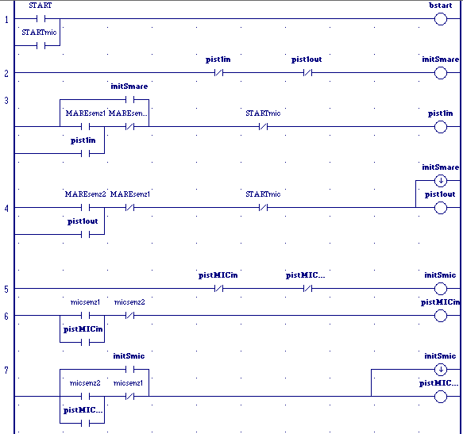

Fig.2. Ladder logic code

## PACEdge

Using the information received by the edge device we can graph out and monitor multiple parameters of the pneumatic circuit.

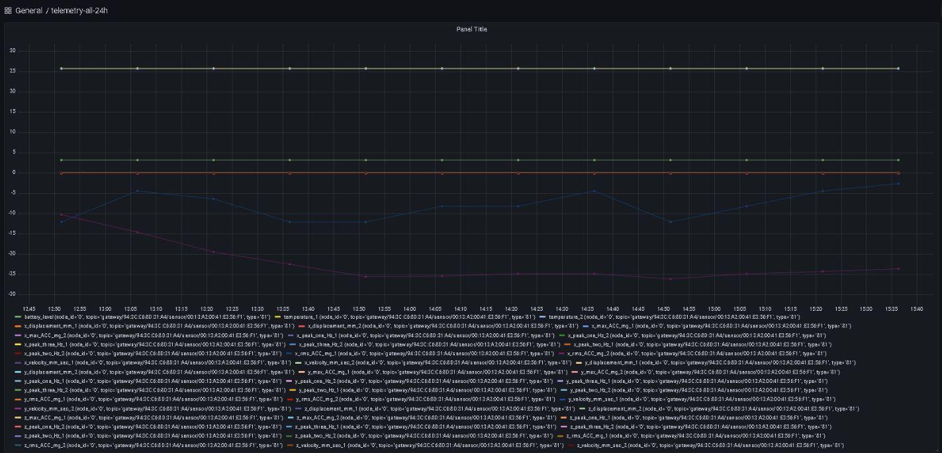Fig.3.Grafana graph of pressure in the system over time

# pysical configuration

## Pneumatic kart

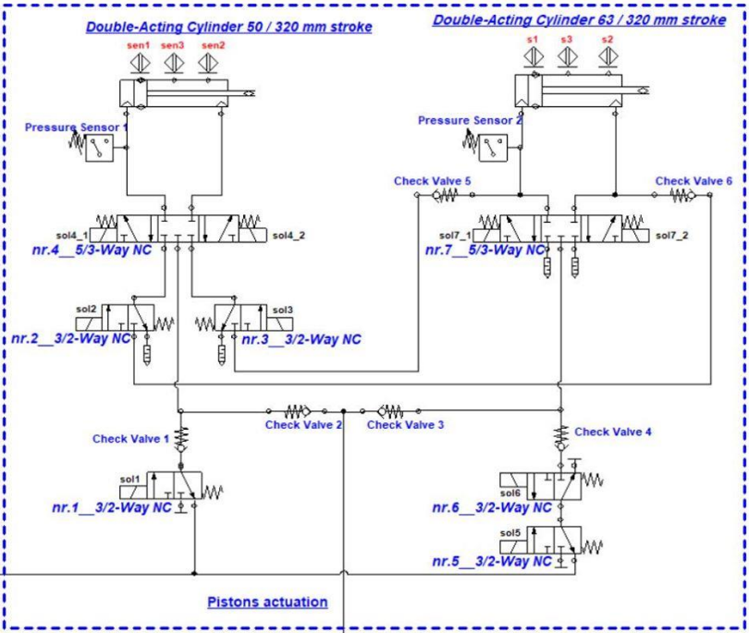The main pneumatic circuit is made out a 3/2 directional valve, used in eco mode when the Ø50 mm is in use, a one way valve, a 5/3 directional valve with the purpose of moving the Ø50 mm piston, proximity sensors and another 3/2 valve used in ecoboost mode redirecting air from the exhaust of the Ø50 mm into the Ø63 mm cylinder.

Fig.1. Pneumatic circuit

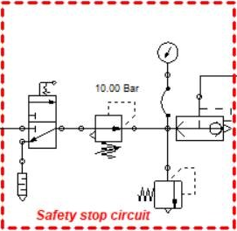

Fig.1. Safety stop circuit

## Experimental stand

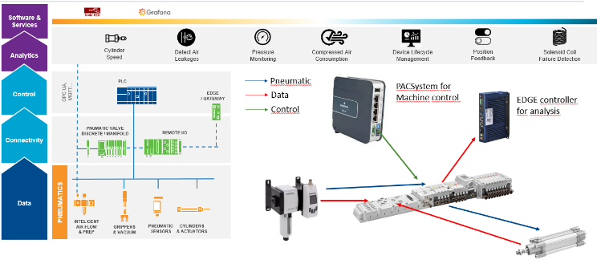Fig.1.

The connecting piece in the circuit is the AES bus coupler to which all other components are connected:

* The PAC is connected via a M12-D to ethernet adaptor cable, from a LAN2 interface of the PAC to the X7E1 port of the BUS and it makes connection between the programed logic and the inputs/outputs (sensors/valves).
* The EDGE controller is connected via a M12-A to USB cable that transmits I/O data for analysis.
* The AF2 IO-Link is connected via a M12-A splitter cable connected to the 2AI2M12-E I/O module for flow and pressure measurements. It also serves the purpose of filtering and preparing the air entering the pneumatic circuit.
* Valves are directly mounted to the bus coupler as modules while input sensors are connected through input modules.
* The I/O modules are connected directly creating, together with the bus coupler, the valve island diagramed below:

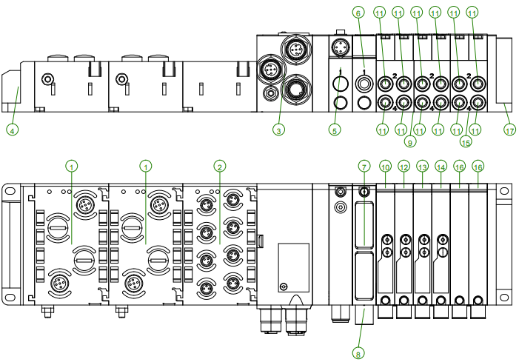Fig.1. Valve island – bus coupler with modules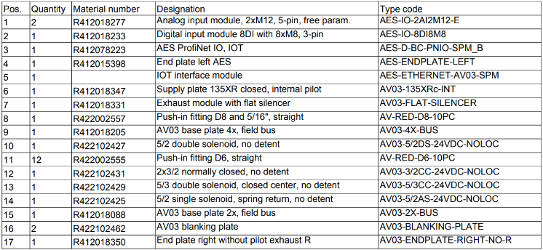Fig.1. Modules designation

##### Acknowledgment

This project couldn’t be realized without all the support we got from POLITEHNICA University of Bucharest, TechCon the representants at Emerson and Aventics, prof. Ghinea Mihalache and everyone else that offered assistance, technical expertise, material or space and tools.

##### References

1. “What is the PAC”, https://blog.acdist.com/what-is-the-pac-programmable-automation-controller
2. “The Advantages of Pneumatic Systems ”https://www.bestpneumatics.com/2018/05/31/the-advantages-of-pneumatic-systems/
3. “Industrial Automation Control” https://www.emerson.com/documents/automation/brochure-pacsystems-industrial-automation-control-overview-pacsystems-en-7200068.pdf
4. “PACEdge Software for Edge Computing” https://www.emerson.com/documents/automation/product-datasheet-pacedge-software-computing-devices-pacsystems-en-7205588.pdf
5. “PLC VS. PAC: WHAT’S THE DIFFERENCE?” https://arnoldmachine.com/resources/plc-vs-pac-what-s-the-difference/#:~:text=The%20most%20notable%20difference%20between,capability%20between%20the%20two%20computers.